

Arab Academy for science Technology and Maritime Transport
College of Computing and Information Technology
Computer Science Department
Database Project

Section in Alexandria Library
Dr. Nada Hany

# | Student Name | Registration # | ERD and  Schema  /15 | Table Creation  /7 | Insert Data  /3 | Query  Data  /5 | Total  /30 | Bonus  /5 | Total
1 | Abdelrhman  Ahmed | 16101710
2 | Seif El din  Nasser | 16102210

Presented by:
Abdelrhman Ahmed Mohamed 16101710
Seif El din Nasser 16102210

Content :
- Project Definition
- Project ERD
- Project Schema
- Project Table Creation
- Project Table insertion
- Project Queries

- Project Definition

- The library section identified by children’s library and library of starch and ID.
- Librarians are identified by their ID, ages, names, addresses and salaries.
- Assistants are identified by their ID, ages, names, addresses and salaries.
- Children participate in the Library section.
- Children are identified by their ID, ages and names.
- Books are identified by its ID and name.
- Halls are identified by its Hall Number, department, age range.
- Activities has name and Type of activity.
- In library section work four librarians and three assistants.
- Activities are organized by Librarians.
- Many children are participate in many activities.
- A Child can borrow many books.
- Books are Stored in different halls according to the children age.

- Project ERD

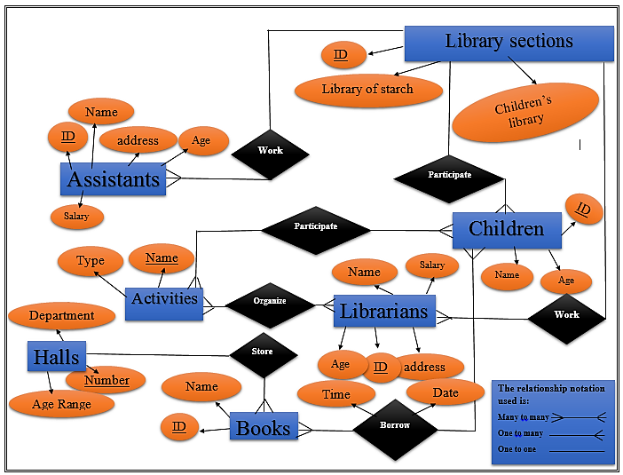

- Project Schema

Library sections: -
Library of starch, Children’s Library, ID
Assistants: -
Address, Age, Salary, Name, ID, Library section-ID
Activities: -
Name, Type
Halls: -
Department, Number, Age Range
Books: -
ID, Name, children-ID
Store:-
Halls-Number, Books-ID
Children: -
Name, ID, Age, Library section-ID
Participate:-
Children-ID, Activity-Name
Librarians: -
Address, Age, Salary, Name, ID, Library section-ID
Organize: -
Librarians-ID, Activity –Name

- Project Table Creation

Library section:
create table library_section(
ls_ID number(20) constraint ls_ID_pk primary key,
ls_library_of_strach varchar(45) constraint ls_library_of_strach_nn not null ,
ls_children_library varchar(45) constraint ls_children_library_nn not null );

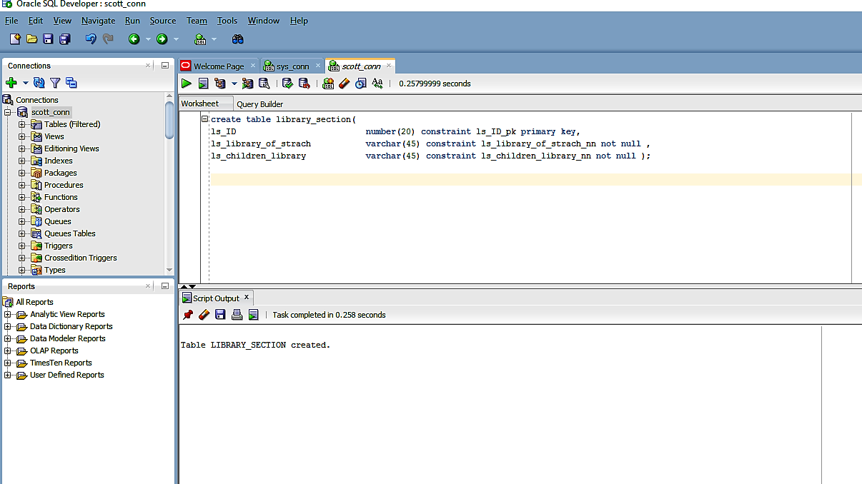

Assistants:

create table assistants(
a_ID number(20) constraint a_ID_pk primary key,
a_address varchar(45) constraint a_address_nn not null ,
a_age number(20) constraint a_age_nn not null ,
a_salary number(20) constraint a_salary_nn not null,
a_name_as varchar(45) constraint a_name_nn not null,
ls_ID number(20) constraint a_ls_ID_fk references library_section(ls_ID) );
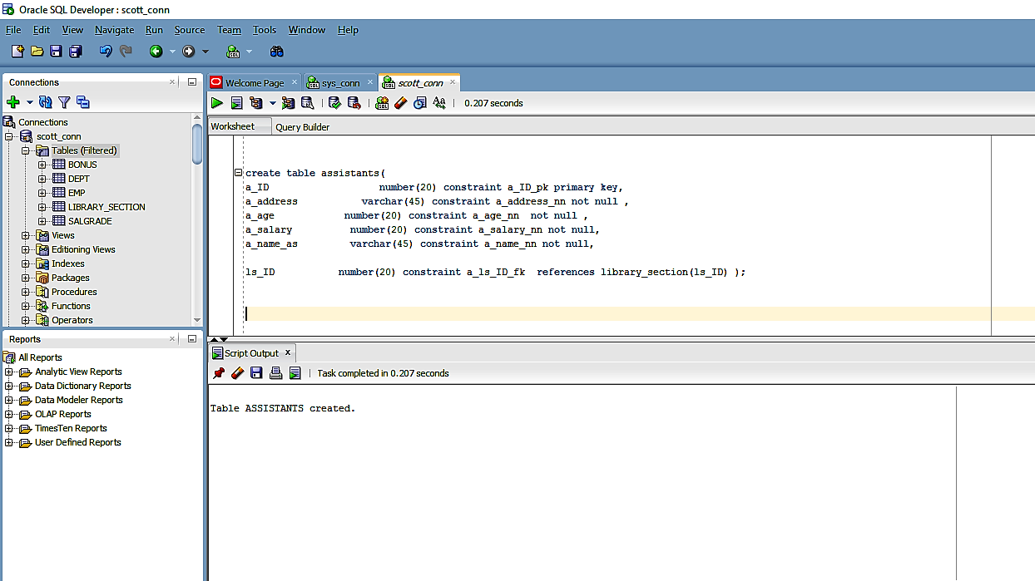
Activities:

create table activities(
ac_name varchar(45) constraint name_nn primary key,
ac_type varchar(45) constraint ac_type_nn not null);

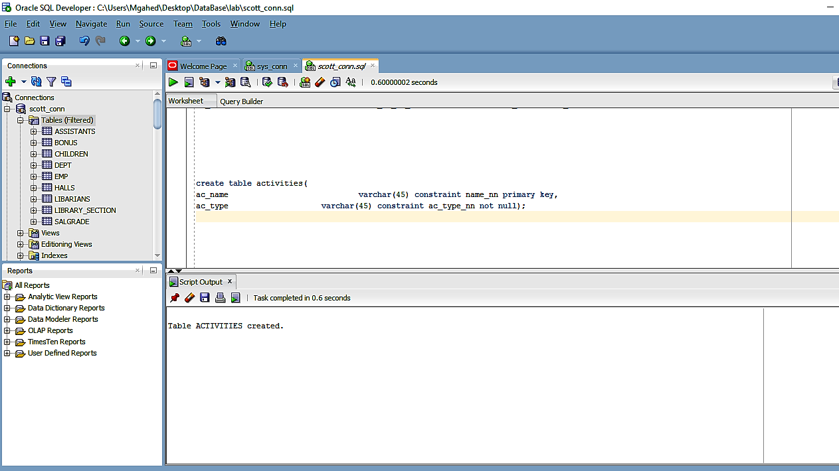

Halls:
create table halls(
h_number number(20) constraint h_number_pk primary key,
h_department varchar(45) constraint h_department_nn not null ,
h_age_range number(20) constraint h_age_range_nn not null );

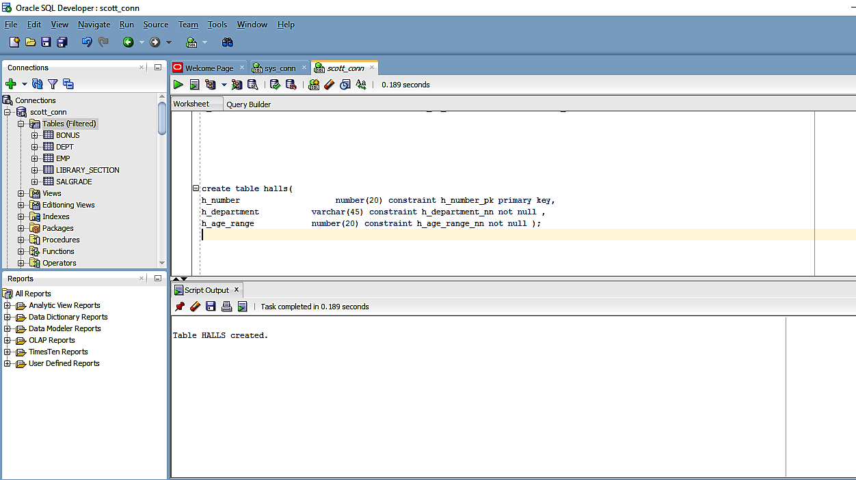

Books:

create table books(
b_ID number(20) constraint b_ID_pk primary key,
b_name varchar(45) constraint b_name_nn not null,
h_number number(20) constraint h_number_fk references halls(h_number));

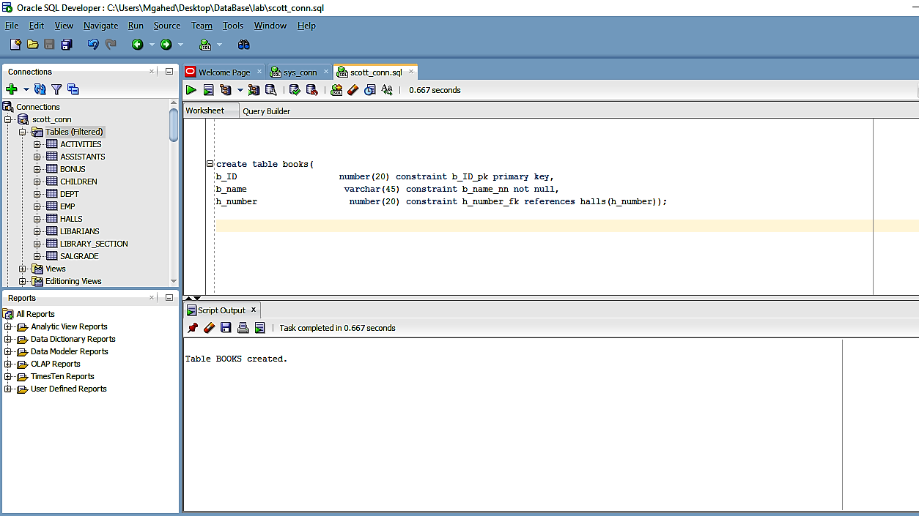

Children:

create table children(
c_ID number(20) constraint ID_c primary key,
ls_ID number(20) constraint ls_ID_fk references library_section(ls_ID),
c_age number(20) constraint c_age_cnn not null,
c_name varchar(45) constraint c_name_cnn not null);

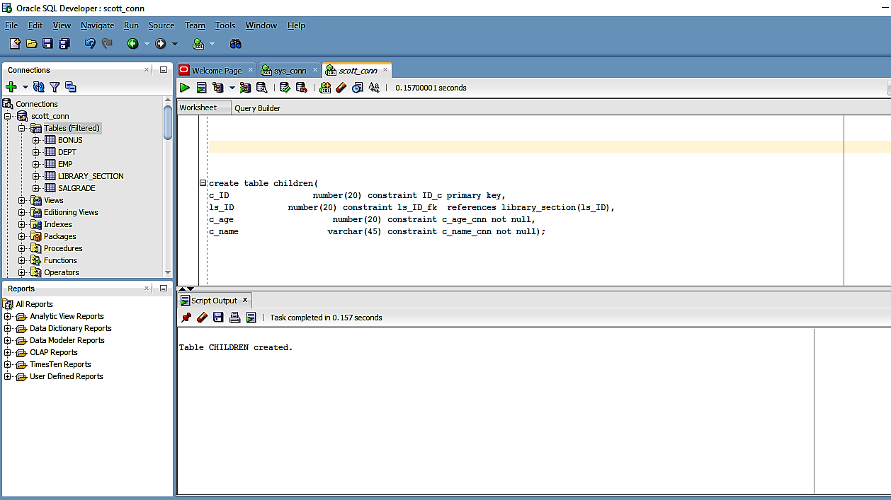

Participate:

create table participate(
c_ID number(20) constraint p_c_ID_fk references children(c_ID),
ac_name varchar(45) constraint p_ac_name references activities(ac_name));

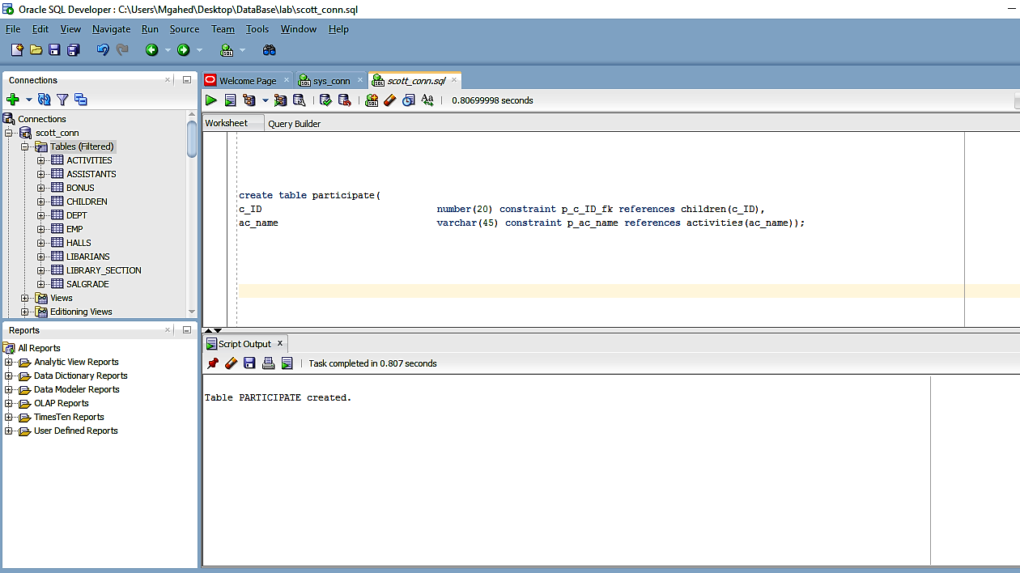

Librarians:

create table libarians(
l_ID number(20) constraint l_ID_pk primary key,
l_address varchar(45) constraint l_address_nn not null ,
l_age number(20) constraint l_age_nn not null ,
l_salary number(20) constraint l_salary_nn not null,
l_name varchar(45) constraint l_name_nn not null,
ls_ID number(20) constraint l_ls_ID_fk references library_section(ls_ID));
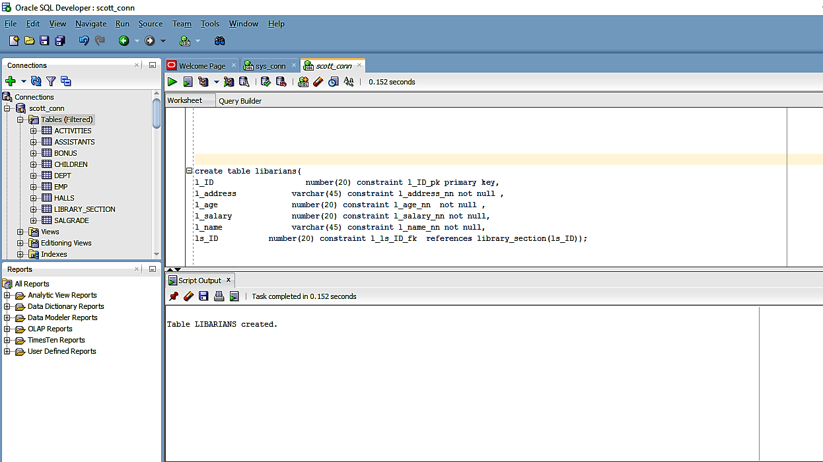
Organize:

create table organize(
l_ID number(20) constraint o_l_ID_fk references libarians(l_ID),
ac_name varchar(45) constraint o_ac_name references activities(ac_name));

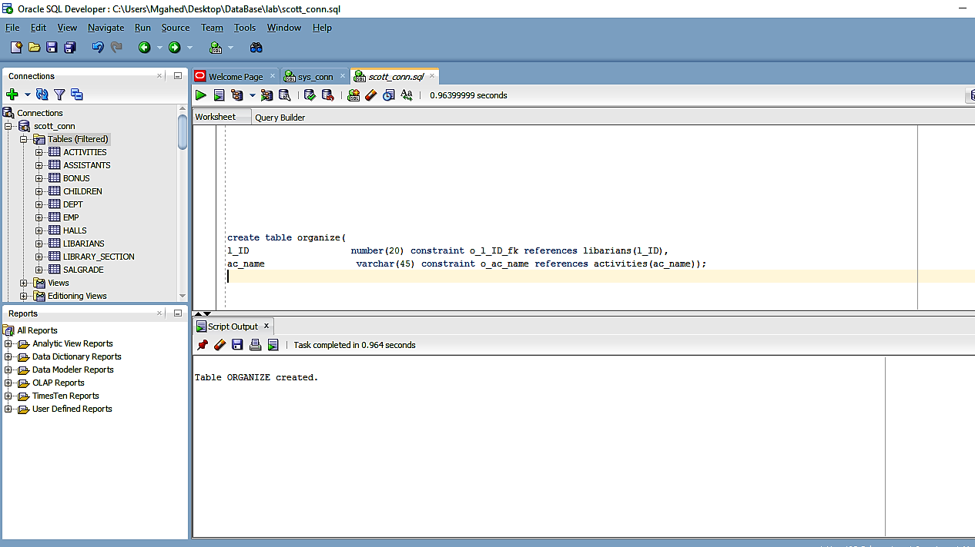
Borrow:
create table borrow(
br_date varchar(20) constraint br_date_nn not null,
br_time varchar(20) constraint br_time_nn not null,
b_ID number(20) constraint br_b_ID_fk references books(b_ID),
c_ID number(20) constraint br_p_c_ID_fk references children(c_ID));
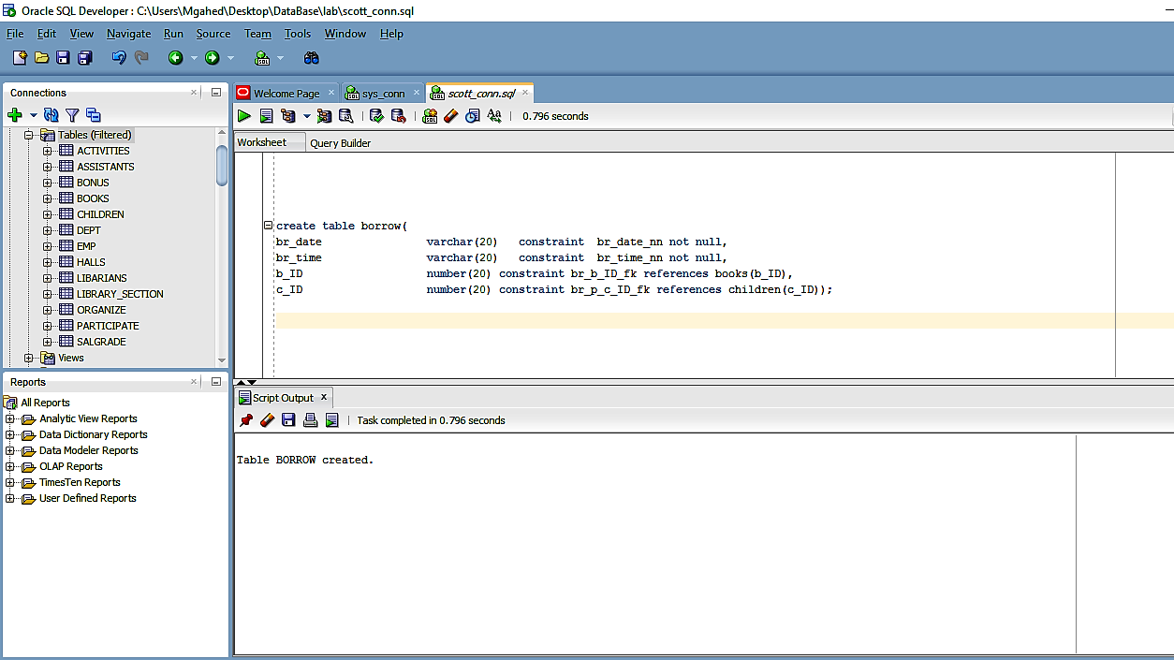

- Project Table insertion
Library section:

insert into library_section(ls_ID,ls_library_of_strach,ls_children_library)
values(13496,'Strach1','children1');
insert into library_section(ls_ID,ls_library_of_strach,ls_children_library)
values(13497,'Strach2','children2');
insert into library_section(ls_ID,ls_library_of_strach,ls_children_library)
values(13498,'Strach3','children3');

select * from library_section;

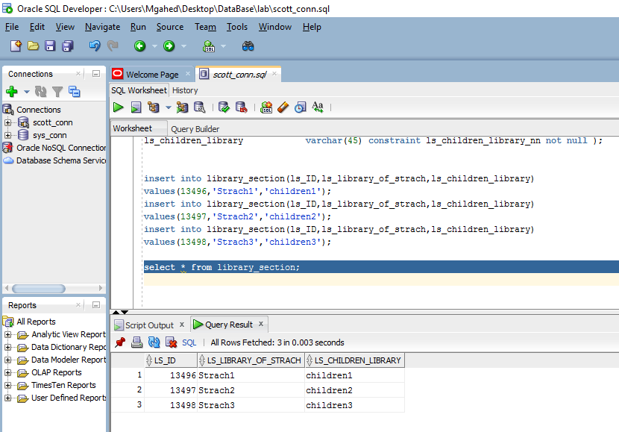
Assistants:

insert into assistants(a_ID,a_address,a_age,a_salary,a_name_as,ls_ID)
values(15496,'smouha',30,2000,'Ahmed mohamed',13496);
insert into assistants(a_ID,a_address,a_age,a_salary,a_name_as,ls_ID)
values(15497,'sidigaber',33,2500,'Mazen mohamed',13496);
insert into assistants(a_ID,a_address,a_age,a_salary,a_name_as,ls_ID)
values(15498,'miami',25,1500,'Abdelrhman Mgahed',13497);
insert into assistants(a_ID,a_address,a_age,a_salary,a_name_as,ls_ID)
values(15499,'al ibrahimia',36,3000,'Ammar magdy',13498);
insert into assistants(a_ID,a_address,a_age,a_salary,a_name_as,ls_ID)
values(15500,'smouha',35,3000,'Ahmed magdy',13496);

select *from ASSISTANTS;
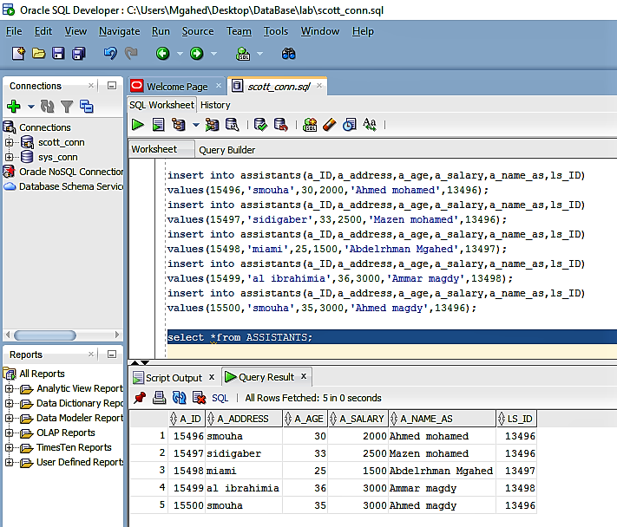
Activities:
insert into activities(ac_name,ac_type)
values('Video games','Entertament');
insert into activities(ac_name,ac_type)
values('Playing Football','Entertament');
insert into activities(ac_name,ac_type)
values('Reading books','Educational');
insert into activities(ac_name,ac_type)
values('Programming','Educational');

select *from ACTIVITIES;
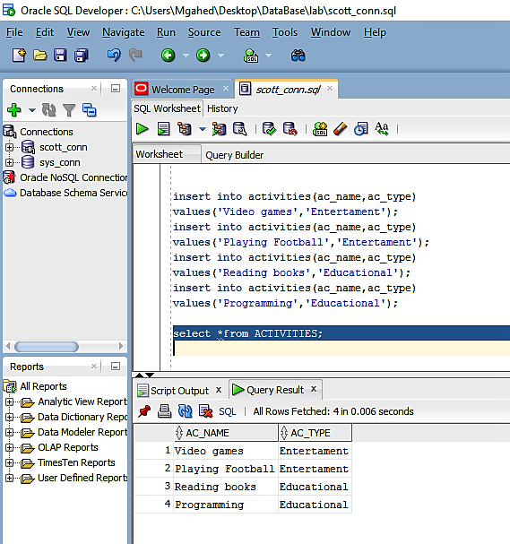
Halls:
insert into halls(h_number,h_department,h_age_range)
values(1,'Computing',35);
insert into halls(h_number,h_department,h_age_range)
values(2,'games',16);
insert into halls(h_number,h_department,h_age_range)
values(3,'Reading',40);
insert into halls(h_number,h_department,h_age_range)
values(4,'Chidren',10);

select *from halls;
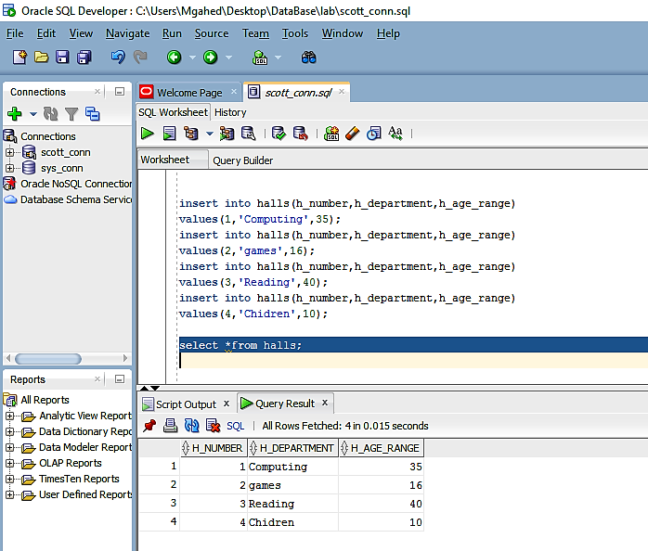
Books:
insert into books(b_ID,b_name,h_number)
values(1000,'Intro to DataBase',1);
insert into books(b_ID,b_name,h_number)
values(1001,'Intro to Problem Solving',1);
insert into books(b_ID,b_name,h_number)
values(2000,'Watch Dogs',2);
insert into books(b_ID,b_name,h_number)
values(2002,'GTA V',2);
insert into books(b_ID,b_name,h_number)
values(3000,'The Fault in our Stars',3);
insert into books(b_ID,b_name,h_number)
values(4000,'Child Trip',4);

select *from books;
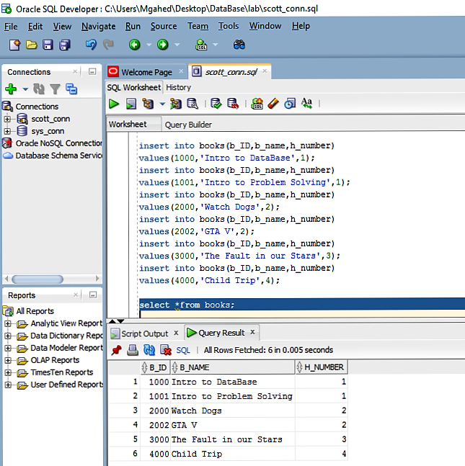
Children:
insert into children(c_ID,ls_ID,c_age,c_name)
values(198,13496,15,'Adam Hammam');
insert into children(c_ID,ls_ID,c_age,c_name)
values(190,13496,19,'Hamza Hammam');
insert into children(c_ID,ls_ID,c_age,c_name)
values(200,13497,12,'Abdelrhman Zein');
insert into children(c_ID,ls_ID,c_age,c_name)
values(202,13498,10,'Ahmed Mohamed');

select *from children;
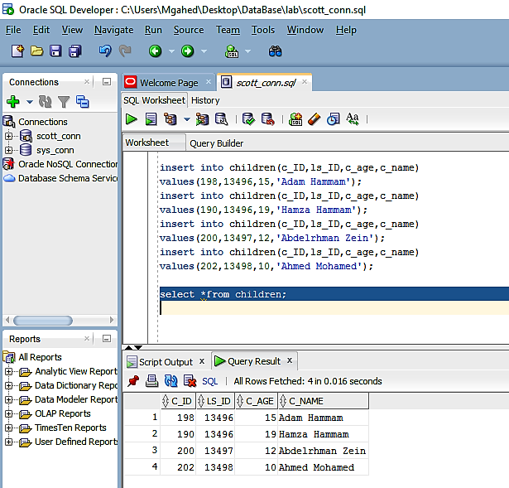
Participate:
insert into participate(c_ID,ac_name)
values(198,'Video games');
insert into participate(c_ID,ac_name)
values(190,'Video games');
insert into participate(c_ID,ac_name)
values(200,'Video games');
insert into participate(c_ID,ac_name)
values(202,'Reading books');

select *from PARTICIPATE;
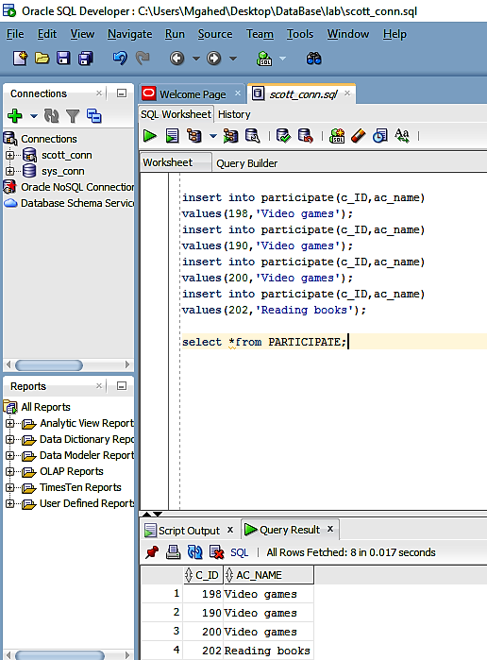
Librarians:
insert into libarians(l_ID,l_address,l_age,l_salary,l_name,ls_ID)
values(5000,'smouha',36,5000,'Magdy Mohamed',13496);
insert into libarians(l_ID,l_address,l_age,l_salary,l_name,ls_ID)
values(6000,'mandra',39,6000,'Mazen Mohamed',13496);
insert into libarians(l_ID,l_address,l_age,l_salary,l_name,ls_ID)
values(7000,'mandra',36,5000,'Magdy Ahmed',13497);

select *from LIBARIANS;
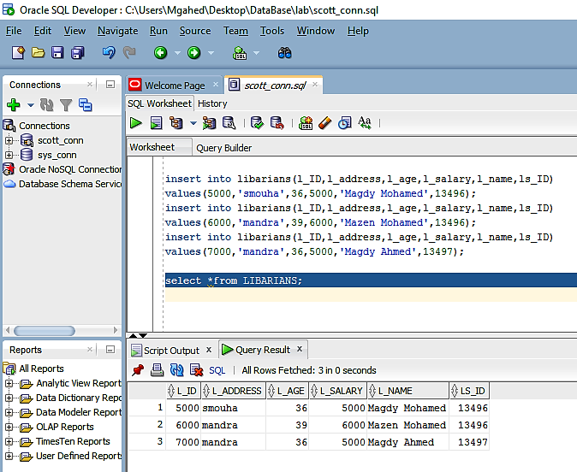
Organize:
insert into organize(l_ID,ac_name)
values(5000,'Reading books');
insert into organize(l_ID,ac_name)
values(6000,'Reading books');
insert into organize(l_ID,ac_name)
values(7000,'Reading books');

select* from ORGANIZE;
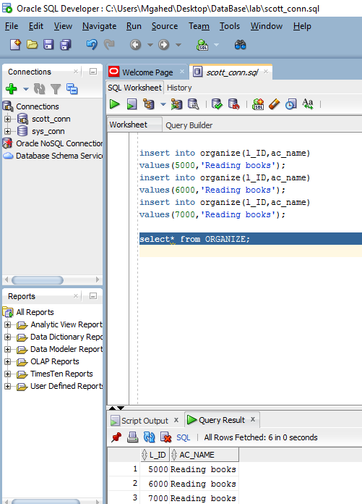
Borrow:

insert into borrow(br_date,br_time,b_ID,c_ID)
values('25/10','2:00',1000,198);
insert into borrow(br_date,br_time,b_ID,c_ID)
values('29/10','5:00',2000,198);

select *from borrow;
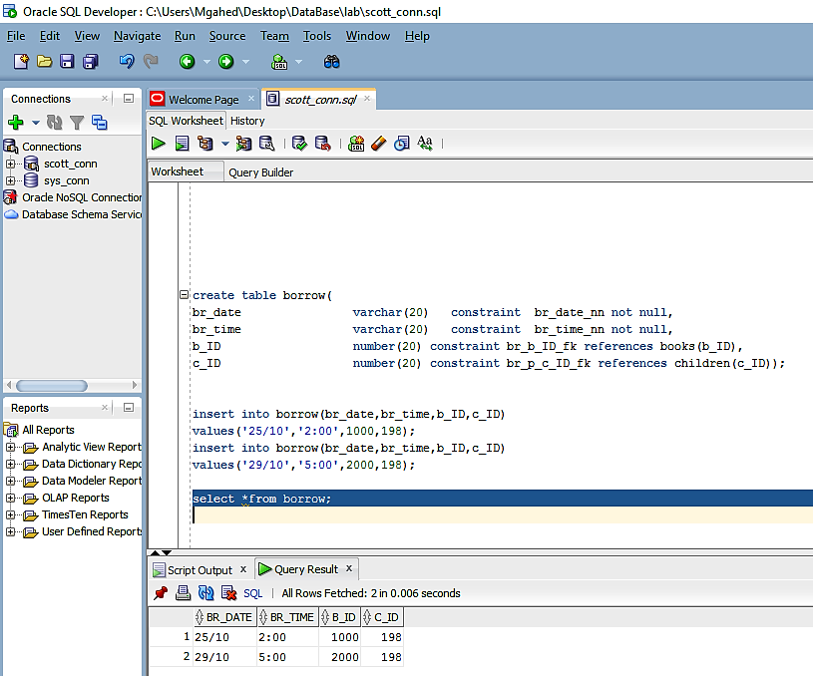
- Project Queries

select l_name,l_age,a_name_as,a_age
from LIBARIANS,ASSISTANTS
Where a_salary > 2000
and l_salary > 5000;
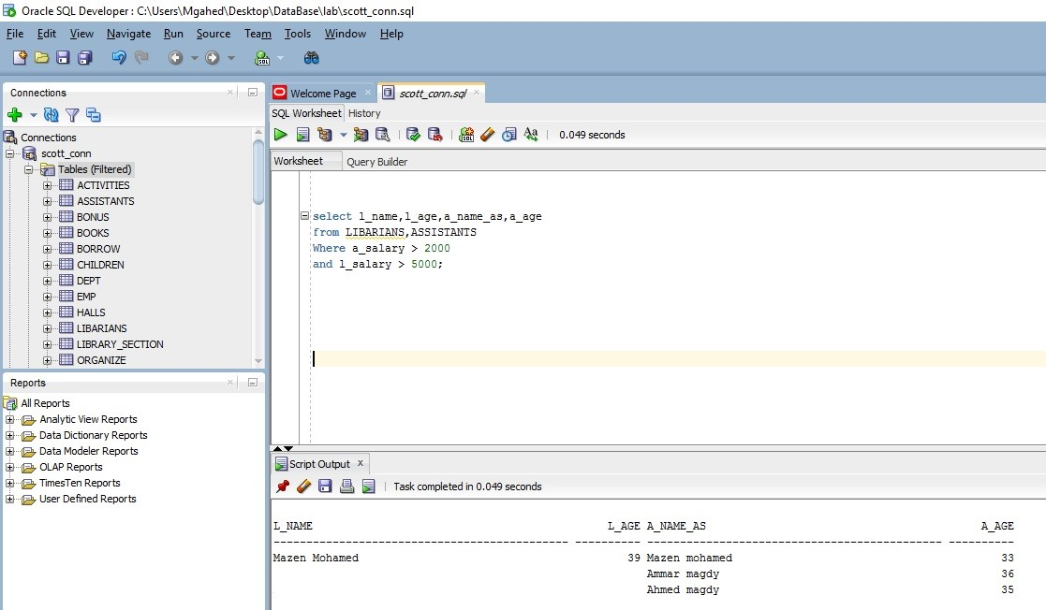
select c_name,c_ID,c_age,ac_name
from CHILDREN,ACTIVITIES
where ac_name = 'Video games';
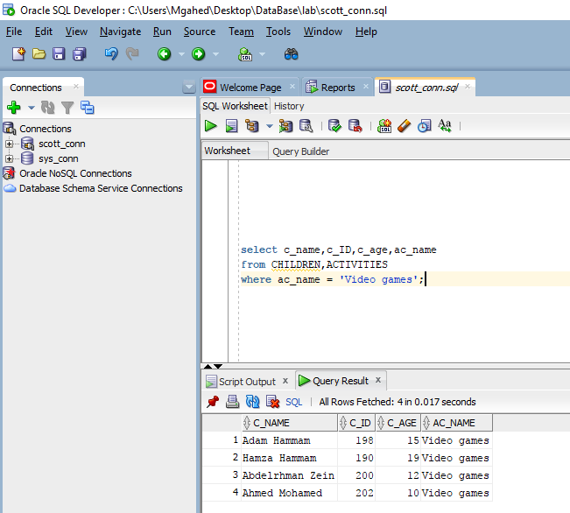
+Bonus

